Feasibility

Introduction
Feasibility aims to automate various aspects of urban and building layout design. By leveraging desktop-based platforms such as Dynamo and the web, it seeks to provide a flexible, efficient, and scalable way to design and manipulate parking layouts, erven (plot) layouts, and building massing in the future. The project encapsulates a variety of geometrical and computational operations required to create complex urban layouts, making it an invaluable tool for architects, urban planners, and civil engineers.

What does the package do?
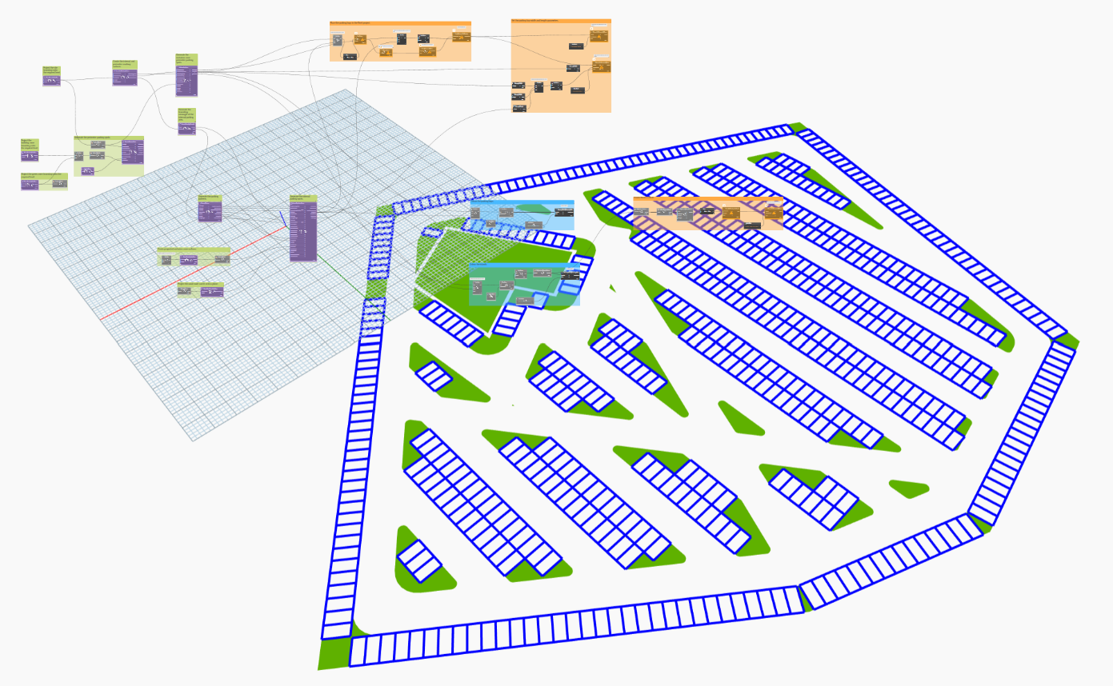
The Dynamo package currently contains 12 nodes, primarily built out of Dynamo out-of-the-box nodes. The nodes automate the development of surface parking with various patterns and parameters to fine-tune the parking layouts. Using the feasibility parking workflow in combination with generative design is a powerful way of producing layouts that optimally use available space. The nodes do not contain any external packages and have been tested on Dynamo v 3.3.0 and Revit 2025.4.
Figure 1Example parking layout developed using the Feasibility package.

Nodes
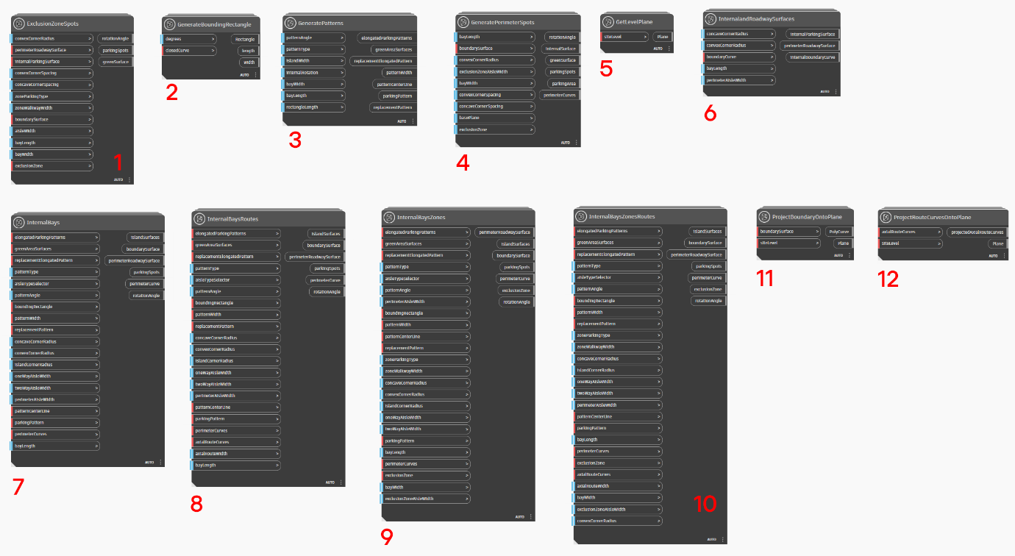
The nodes are described below:
Figure 2 The Feasibility surface parking nodes

- ExclusionZoneSpots: Creates parking spots around areas of a parking layout called exclusion zones. The exclusion zones are parts of the layout where parking is not required.
- GenerateBoundingRectangle: Generates a rectangle around a closed curve, ensuring the curve is completely encapsulated. The rectangle is needed to layout the internal parking bays.
- GeneratePatterns: Creates the non-interlocking, interlocking, and herringbone parking patterns.
- GeneratePerimeterSpots: Generates parking bays along the perimeter of a parking layout. An important feature of the node is that it includes parameters required to adjust the corner spacings of the parking spots.
- GetLevelPlane: Gets a plane from a Revit level object. This node is useful when creating parking spots on a specific level within a Revit project.
- InternalandRoadwaySurfaces: Generates a perimeter roadway surface and a surface representing the internal areas of the parking layout.
- InternalBays: Produces the internal parking bay elements without exclusion zones and movement routes.
- InternalBaysRoutes: Creates the internal parking bay elements and allows the delineation of movement routes with curve elements.
- InternalBaysZones: Generates the internal parking bay elements and allows the delineation of exclusion zones where parking spots will be excluded.
- InternalBaysZonesRoutes: Creates the internal parking bay elements and allows the delineation of movement and exclusion zones.
- ProjectBoundaryOntoPlane: To project the boundary of a surface representing the parking layout area onto a Revit level.
- ProjectRouteCurvesOntoPlane: Projects curves for the movement onto a Revit level.

Sample files
The “extras” folder contains sample files. It is recommended to test these files before using the package to ensure everything works correctly.
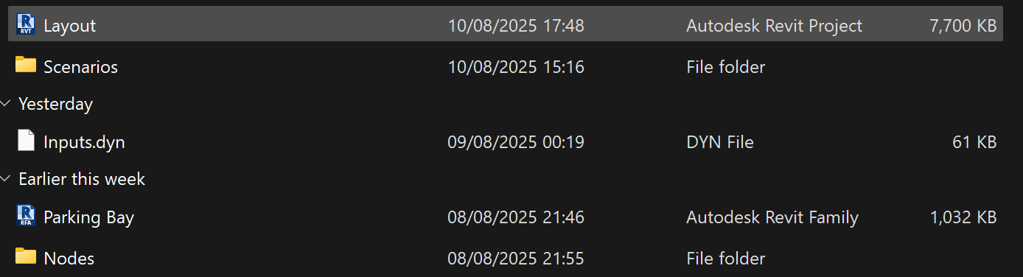
Figure 3 The sample files.
- Layout file: On the “Ground Level”, the layout Revit file contains example parking layouts represented by filled regions and detail lines. The .dyn files contained the “Scenarios” folder, which references the elements in the layout file.
- Scenarios: Includes eight example parking scenarios showing how the package could be used. The files allow pushing the parking elements into Revit as native objects.
- Parking Bay: A parametric Revit parking bay family.
- Nodes: Sample .dyn files showing key nodes working in isolation.

Known issues and Limitations
The following are a few known issues. Please report and other issues on the Dynamo forum.
- Scale: Using meters gives the best results, so set your Revit project units to meters. Working in millimetres can cause issues in Dynamo’s geometry rendering because the layout may be too large for Dynamo’s extents, depending on the area.
- Filleting of internal islands: Depending on layout complexity, internal parking islands may be returned without fillets. This is likely tied to limits in Dynamo’s ASM geometry engine that prevent complex corners from being filleted.
- Straight edges: The package currently supports only layouts with straight edges. Curved edges will produce errors

Future development
The aim is to convert the Feasibility package into C# zero-touch nodes to improve speed, strengthen error handling, and add features such as signage, curved layout edges, additional parking types, parking spot numbering, entrance markers, and more. Some of this work is already underway and can be viewed in the open source GitHub repository. The developer, Bayo Windapo, is currently focused on a PhD at ETH Zurich and cannot divert development time to the project. Developers with Dynamo and C# zero-touch experience who are willing to continue the project as open source are welcome to contact Bayo on LinkedIn for details on the development structure.

